EXAM UseCase-1

CSV->HDFS-> MapReduce->HDFS

Problem Statement
A social-media platform needs to determine the frequency of each hashtag from user posts stored in HDFS. Because the mapper and reducer are written in Python, the pipeline will utilize Hadoop Streaming to execute the MapReduce job across the distributed cluster.

HDFS Storage

- Process:
- Data Creation
-Making Directory and starting all sh
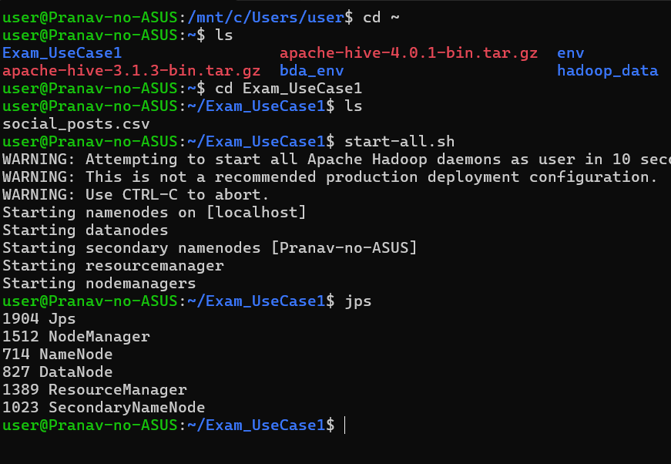
- Data Ingestion
- Creating HDFS and put csv file in it
Hdfs dfs –mkdir –p /directory_name/
# to put: Hdfs dfs –put /directory name/
To check list we cant use ls
instead use : hdfs dfs –ls /directory_name/
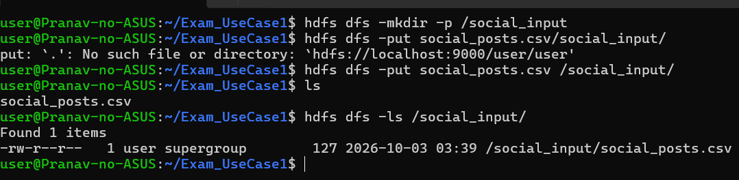
- Data Processing with MapReduce
- Creating mapper.py and combiner.py with reducer.py
- Mapper.py maps all the data which needs to be processed
- Combiner.py calculates things locally reducing network load
- Reducer.py aggregates all the results from combiner.py
DataFlow: mapper.py->combiner.py->reducer.py
Remember code of combiner.py and Reducer.py is same in case of sum and count but in case of average it will be different
Also don’t just use space separation while printing in case of combiner coz it will be input for reducer which will be unable to use .split(“\t”,1)
Mapper.py:
#!/usr/bin/env python3
import sys
for line in sys.stdin:
line=line.strip()
words=line.split()
for word in words:
if(word.startswith("#")):
print(f"{word}\t1")
Combiner.py:
DON’T DO THIS
Instead use: print(f”{current_word}\t{current_count}”)
This will be used to split in reducer
Code:
#!/usr/bin/env python3
import sys
current_word =None
current_count=0
for line in sys.stdin:
line=line.strip()
if not line:
continue
try:
word,count=line.split("\t",1)
count=int(count)
except:
continue
if current_word==word:
current_count+=count
else:
if(current_word):
print(f"{current_word}\t{current_count}")
current_word =word
current_count=count
if current_word:
print(f"{current_word}\t{current_count}")
Reducer.py
- Remember we can use +1 instead of count in combiner but in reducer the count is not always one(locally calculation is done)
So use +count not +1

Code:
#!/usr/bin/env python3
import sys
current_word=None
current_count=0
for line in sys.stdin:
line=line.strip()
if not line:
continue
try:
word,count=line.split("\t",1)
count=int(count)

except:
continue
if(word==current_word):
current_count+=count
else:
if(current_word):
print(f"{current_word} :{current_count}")
current_word=word
current_count=count

if(current_word):
print(f"{current_word} :{current_count}")
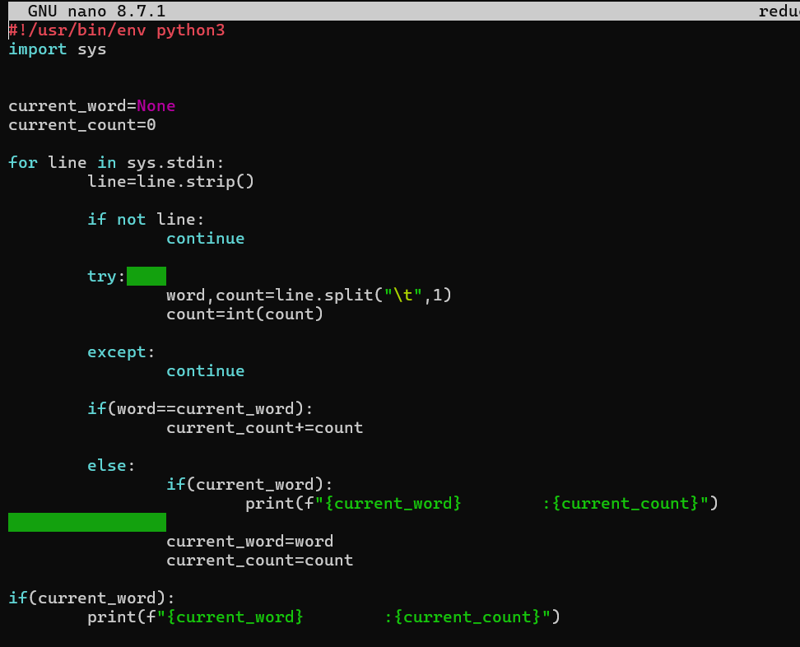
Here the spaces wont be issue (we can use both as it’s the output we will be seeing)
- Initiating streaming
Making files executable
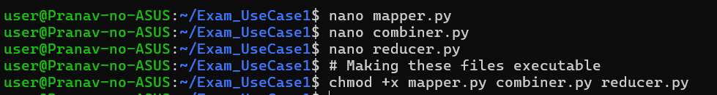

Starting streaming sequence and processing the data using jar:
- JAR acts as a universal translator or bridge between Hadoop's Java architecture and your Python code
Code:
hadoop jar /usr/local/hadoop/share/hadoop/tools/lib/hadoop-streaming-3.3.6.jar \
-file mapper.py -mapper "python3 mapper.py" \
-file combiner.py -combiner "python3 combiner.py" \
-file reducer.py -reducer "python3 reducer.py" \
-input /social_input/social_posts.csv \
-output /social_output
